**UNCOVERING THE GAMING INDUSTRY’S HIDDEN GAMES: A COMPREHENSIVE ANALYSIS OF VIDEO GAMES SALES**

**CONTENT**

**S.NO TITLE PAGE NO.**

**1. INTRODUCTION**

1.1.Overview

1.2.Purpose

**2.** **PROBLEM DEFINITION**

2.1.Empathy map

2.2.Brainstorming

**3.** **RESULT**

**4. ADVANTAGES & DISADVANTAGES**

**5. APPLICATION**

**6. FUTURE SCOPE**

**7. CONCLUSION**

**1.INTRODUCTION**

**1.1.Overview**

The gaming industry is a constantly evolving and growing industry ,with new games being released every year .While many of these games receive a lot of attention and hype, there are also hidden gems that don’t receive as much recognition but are still great games worth playing.

**1.2.Purpose**

The purpose of discovering gaming hidden gems is to broaden your gaming experience beyond the popular titles and franchises that receive lot of attention and hype. By exploring lesser-known games , you can discover unique and innovative game play experiences that you would not find in more mainstream titles. Additionally, playing hidden gems can provide a sense of discovery and exploration that is often missing in bigger games .You might feel like you’re discovering something new and exciting that not many people know about, which can be rewarding experience.

**2.PROBLEM DEFINITION**

**2.1. Empathy map**

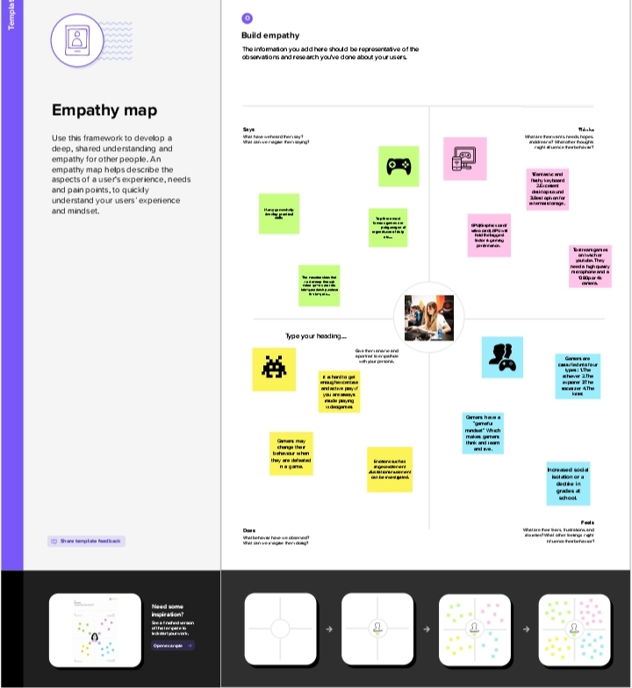

**2.2.BRAINSTROMING MAP**



**3.RESULT**

**Video games sales dashboard**

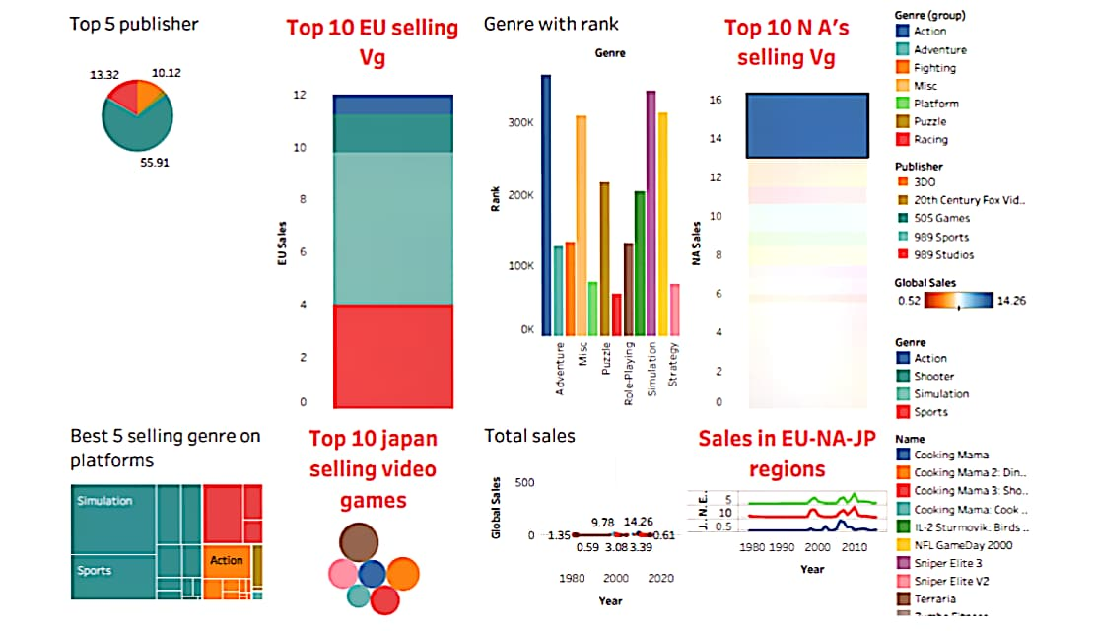

**Video games sales story**

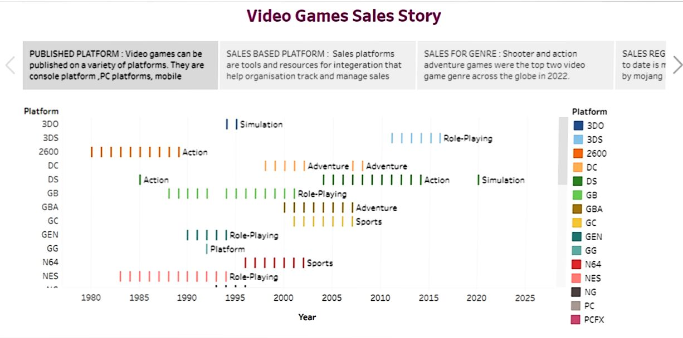

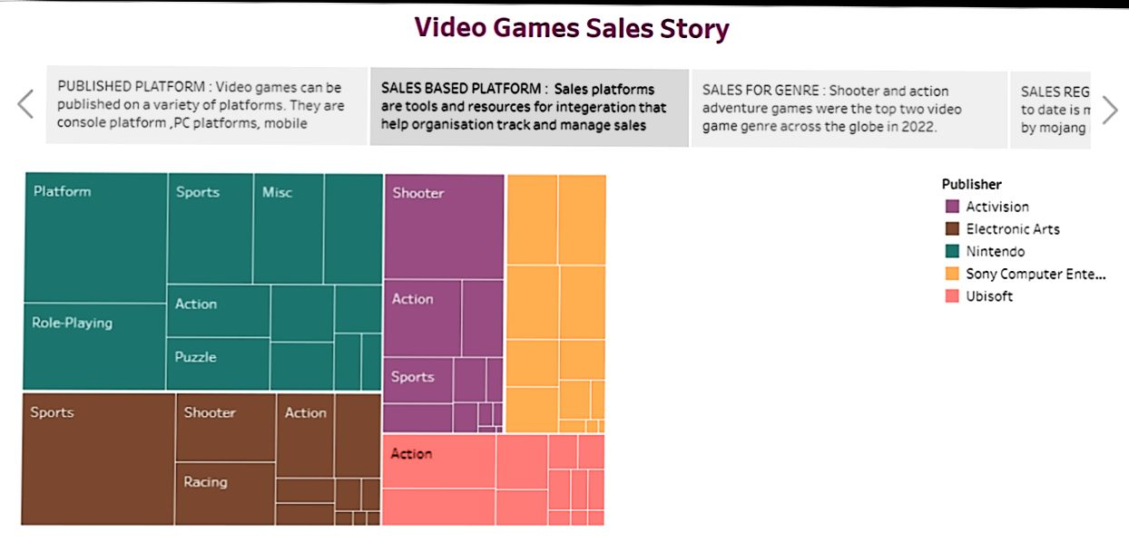



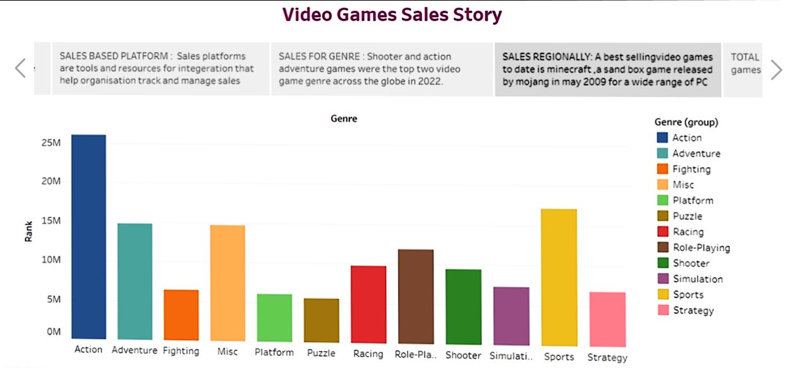

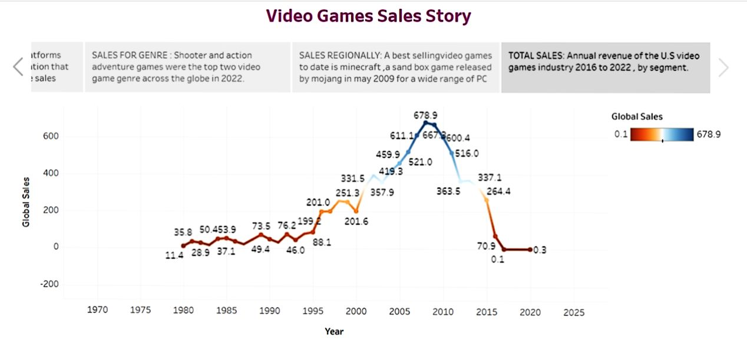

**4. ADVANTAGES & DISADVANTAGES**

**Advantages:**

* INCREASED REVENUE: One of the most obvious advantages of video game sales is that they generate significant revenue for the companies that produce and distribute them.
* JOB CREATION:The video game industry provides employment opportunities for a wide range of professionals, including programmers, artists, designers, marketers and customers support staff.
* SOCIAL BENEFITS: Video games can also provide social benefits by allowing players to connect with others who share similar interests.
* TECHNOLOGICAL ADVANCEDMENT: The development of video games requires advanced technology and as the industry continues to go it pushes the boundaries of what is possible with new technologies.
* SOCIALIZATION: Multiplayer games allow players to communicate and work together promoting team work, communication and socialization skills.

**Disadvantages**

* ADDICTION: Some individuals can become addicted to gaming, leading to negative consequences such as neglecting responsibilities social isolation and other health problems.
* HEALTH PROBLRMS: Gaming can lead to a sedentary lifestyle which can increase the risk of obesity, cardiovascular disease and other health problem.
* VIOLENCE: Some games contain violent or graphic content that can desensitize players to violence and contribute to aggressive behavior.
* COST: Gaming can be an expensive hobby requiring the purchase of consoles, games and accessories, as well as internet subscription fees.
* CYBER BULLYING: Online gaming can expose player to cyber bullying, harassment and in appropriate behavior from other players.
* EYE STRAIN: Extended gaming session can lead to eye strain and fatigue , as well as headache and other vision problem.

**5. APPLICATION**

* Video games have been around for decades, providing entertainment for children and adults alike. They have evolved significantly from the early days of computer games and the first versions of Nintendo and Atari.
* The days of pixelated screens and limited sounds are a distant memory as video games have become more life like than ever.
* As technology continues to improves do video games. Video games has become increasingly complex and the cost creating a game to run on one of the major consoles has risen with this greater complexity.
* Today, 66% of Americans-more than 215 million people of all ages and backgrounds-play video games regularly.
* The quarters of players over rating and the average age of a video game player is 33.Accross all ages, players are about half females and half male.
* Play is also an important part of learning and nearly 90% of all Americans see video games as helping to build skills like problem solving, conflict resolution and leadership.

**6. FUTURE SCOPE**

The gaming industry has an array career choices to offer. It

makes up for a large segment on the employment front to according to statistics shared by the

American Gaming Association , game industry jobs provide employment to as many as 1.7

million individuals, with a employment rate growing by 62,000 jobs every year.

The most myth about game industry job is the lack of

options.However, game careers are not limited to game design and game development. Here

are some game industry jobs, that you can take up as a profession.

**7. CONCLUSION**

Video games are a form of media that is often associated with negative health consequences. However, when games played in moderation and with mindfulness, they are a viable source of stress relieve as well a catalyst for mental health improvement and development of social skills.